**Reading File**

* Command line arguments are stored within the Project properties for Lab01.b.chess file.

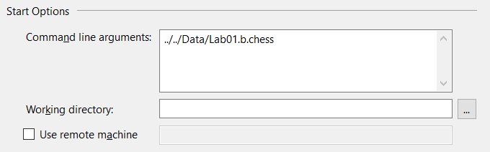

* + If command line arguments are empty, it is set automatically within Main to choose the same file for whatever file.
* As the program proceeds, a Chess Translation method which takes in the file directory checks every specific line of the file.
  + Comments are removed by a Regex pattern that checks for lines with comments attached or comments that take up the whole line.
  + After comments are removed, the information on each line is compared to Regex patterns specifically set for either placement, castling or movement while, either of them are checked at the same time.

**Placement**

* Placement is simply just returning the captured groups within the Regex pattern and either returning the values or changing the original group to a new string

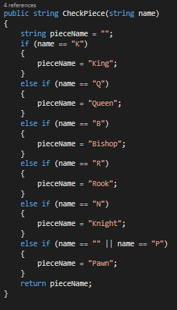

**Movement & Castling**

* On the same level of placement, movement and castling are then checked for either or on each line. 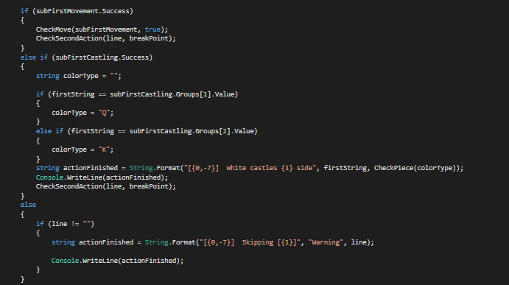
  + No matter what line that matches either castling and movement is then split into two with a counter using string method Substring which breaks at the last whitespace character from the first action.
  + Then I have a separate method that rids of whitespace for the first action and returns the new string.
  + Yet again, the same concept we did before, when we checked if the pieces were either being placed or an action was occurring; we check if it is either movement or castling.
    - If is regular movement and not castling, I dissect each grouping from the Regex that checks for one side and a boolean that determines which side is being checked.
    - For castling, I have a small Regex that check for the two types of castling and then whatever color it is.
  + These actions are the same for both white and black pieces.

**Warnings and Errors**

* If invalid placement, then a warning is prompted returning the line of where it occurred.
* If invalid movement and castling:
  + For white, a warning occurs and skips black’s action.
  + For black, an error occurs and continues onto next line.

**Console Output:**

